1 MS Wored is a application softower . It is use for creating editing and formatting text .
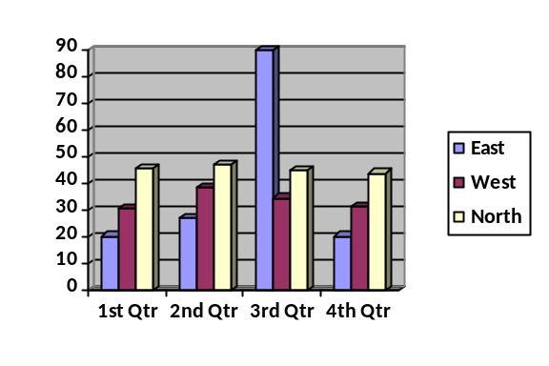

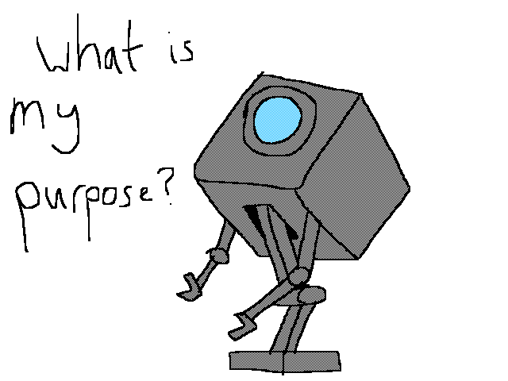



Election
Proton
Neuclious

d.

January Test
Surname | Name | English | German | Computer
Xuereb | Norbert | 85 | 42 | 98
spiteri | Richard | 53 | 45 | 75
Borg | Clive | 55 | 85 | 82
Caruana | Michelle | 45 | 45 | 25
Briffa | Paola | 42 | 25 | 48

